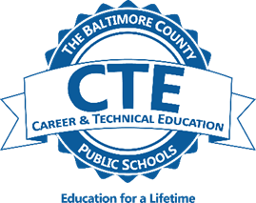
College-Career Research & Development Completer

Introduction to College-Career Research & Development Prerequisite: None
This course provides students with instruction in Maryland’s Career Development Framework, including self-awareness, career awareness and exploration, workplace readiness, career satisfaction, and financial literacy. Students will begin a portfolio to document their career goals, skills, interests, and pathway planning.
Advanced College-Career Research & Development Prerequisite: Successful completion of Introduction to College-Career Research & Development is required.

This course requires students to apply their career development knowledge to further their career preparation. The course explores all aspects of a career, including transitions, advancements, and job satisfaction. Advanced financial literacy, including personal budgeting is taught. Students continue to develop their portfolios. Advanced CCRD is recommended to be taken concurrently with Work-Based Learning Experience to provide the opportunity for students to apply classroom learning in a workplace setting.
CCRD Work-based Learning Experience Prerequisite: Concurrent enrollment in College-Career Research & Development coursework; 16 years of age.

This course requires students to apply their career development knowledge to a work experience in a career area of their choice. Students’ skill development is measured by an individualized learning plan and related reflections. Emphasis is placed on workplace readiness skill development.
This three-credit CTE career-completer program prepares students with the academic, technical, and workplace readiness skills that will enable further education and/or employment in a career field upon graduation from high school. The CCRD program consists of two in-school courses, a portfolio development project, and a mentored work-based learning experience with a focus on workplace readiness skill development. Students will identify a career pathway of interest and determine steps to achieve their education and career goals. Financial literacy and
independence planning are essential components of the CCRD program. Students who successfully complete the
program may earn three articulated college credits with CCBC. Fees may be required.

